Text components

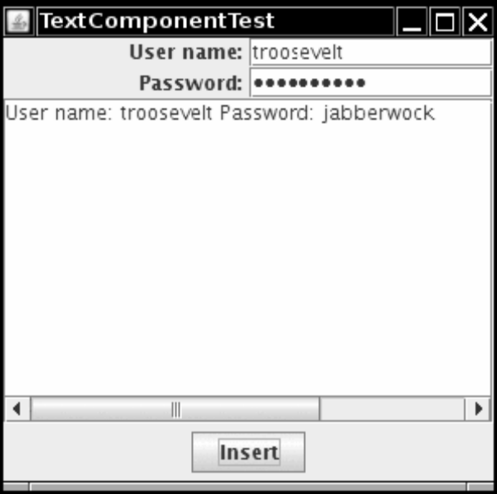

1. import java.awt.*;
2. import java.awt.event.*;
3. import javax.swing.*;
4.
5. /**
6. * @version 1.40 2007-04-27
7. * @author Cay Horstmann
8. */
9. public class TextComponentTest
10. {
11. public static void main(String[] args)
12. {
13. EventQueue.invokeLater(new Runnable()
14. {
15. public void run()
16. {
17. TextComponentFrame frame = new TextComponentFrame();
18. frame.setDefaultCloseOperation(JFrame.EXIT_ON_CLOSE);
19. frame.setVisible(true);
20. }
21. });
22. }
23. }
24.
25. /**
26. * A frame with sample text components.
27. */
28. class TextComponentFrame extends JFrame
29. {
30. public TextComponentFrame()
31. {
32. setTitle("TextComponentTest");
33. setSize(DEFAULT_WIDTH, DEFAULT_HEIGHT);
34.
35. final JTextField textField = new JTextField();
36. final JPasswordField passwordField = new JPasswordField();
37.
38. JPanel northPanel = new JPanel();
39. northPanel.setLayout(new GridLayout(2, 2));
40. northPanel.add(new JLabel("User name: ", SwingConstants.RIGHT));
41. northPanel.add(textField);
42. northPanel.add(new JLabel("Password: ", SwingConstants.RIGHT));
43. northPanel.add(passwordField);
44.
45. add(northPanel, BorderLayout.NORTH);
46.
47. final JTextArea textArea = new JTextArea(8, 40);
48. JScrollPane scrollPane = new JScrollPane(textArea);
49.
50. add(scrollPane, BorderLayout.CENTER);
51.
52. // add button to append text into the text area
53.
54. JPanel southPanel = new JPanel();
55.
56. JButton insertButton = new JButton("Insert");
57. southPanel.add(insertButton);
insertButton.addActionListener(new ActionListener()
59. {
60. public void actionPerformed(ActionEvent event)
61. {
62. textArea.append("User name: " + textField.getText() + " Password: "
63. + new String(passwordField.getPassword()) + "\n");
64. }
65. });
66.
67. add(southPanel, BorderLayout.SOUTH);
68.
69. // add a text area with scrollbars
70.
71. }
72.
73. public static final int DEFAULT_WIDTH = 300;
74. public static final int DEFAULT_HEIGHT = 300;
75.
}

